FOR IMMEDIATE RELEASE September 14, 2021

Contact: Mark Cameron Jamaica Chess Federation www.jamchess.com

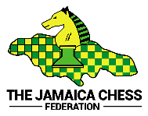

**PRESS RELEASE – JAMAICA’S JAHEIM SMART, RONAK SHEGRIL AND NAJAE POWELL EXCELLED IN RECENTLY CONCLUDED FIDE ONLINE BLITZ AND RAPID PANAMERICAN YOUTH CHESS FESTIVAL 2021**

Kingston, Jamaica –Jamaica was again well represented in a FIDE, the governing body for chess, tournament with 26 players, both boys and girls, in age groups from U-8 years old through U-16 years old. This was another opportunity for our junior players to excel against regional opponents.

In the Blitz tournament, which was played on Saturday, September 11th, we had 6 representatives from U-10 through U-16. Jaheim Smart was our outstanding player, finishing second in the Open U-12 section, with 6/9 points behind the winner, Mauricio Emmanuel Marrujo Pardo, from Chile, who won with 8.5/9 points.

Good performances were also achieved by the following juniors:



In the Rapid tournament played yesterday, Sunday, September 12th, Ronak Shergil and Najae Powell were the outstanding players. Ronak played in the Open U-10 section and finished with 5/7 points, putting him 4th, from a field of 24 players. He defeated players from Peru, Chile, and Brazil.Mateo Henry Palomino Quispe, from Peru wonwith 6.5/7 points.

Najae Powell excelled in the Open U-12 section, also gaining 5/7 points. He performed very well and had a chance to get to 6 points, before succumbing to the highest rated player in the section, Mauricio Emmanuel Marrujo Pardo from Chile.Najae finished 3rd out of 25 players.

Several girls participated in the event, with Amy Stephenson being the top Jamaican performer scoring 4.5/7 points in the Girl U-16 section, followed by Kaity Gayle, who scored 3.5/7 points.

Performances by our players in the Rapid section are summarized below:

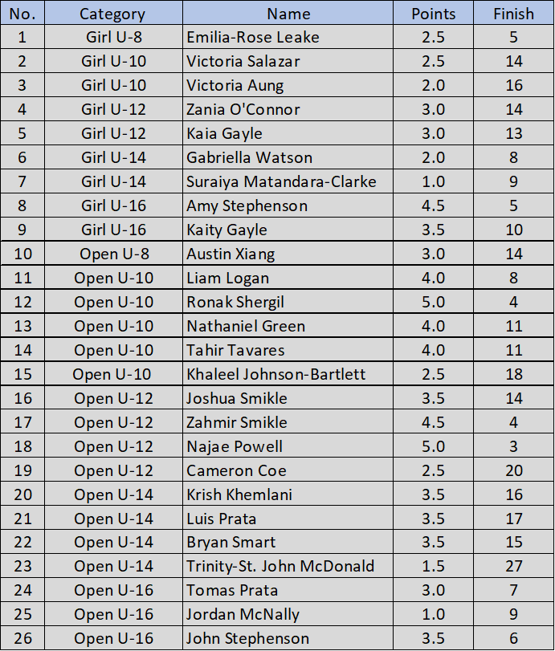

The FIDEOnline Blitz and Rapid XXXI Pan American Youth Chess Festival 2021 was regionally organized by the Confederation of Chess for America (CCA) and the Brazilian Chess Federation (CBX).

National Chess Federations of the Americas were invited to this online event. Becauseof the inability to have an in-person event, this was another opportunity for our junior players to have greatinternational exposure.

Photo 1 – Jaheim Smart

Photo 2 – Ronak Shergil

Photo 3 – Najae Powell

###

About the Jamaica Chess Federation

The Jamaica Chess Federation (JCF) was founded in 1969 and has been affiliated with FIDE, the governing body for chess, since 1972. In its capacity as the governing body for chess in Jamaica, the JCF is devoted to extending the role of chess in the Jamaican society.

For more information about the Jamaica Chess Federation, please visit [www.jamchess.com](http://www.jamchess.com) or contact Mark Cameron at [jamchessfed.public.relations@gmail.com](mailto:jamchessfed.public.relations@gmail.com) or 713-591-1153.